HDI Prediction System: A comprehensive Measure of Well-Being

Project Description:
The HDI Prediction System — also referred to as “Human Development Intelligence” — is an interactive application that predicts and analyzes the Human Development Index (HDI) of a country from its core socioeconomic indicators. Users provide four inputs — life expectancy at birth, mean years of schooling, expected years of schooling, and GNI per capita (PPP $) — and the system returns a predicted HDI score together with its development tier (Very High, High, Medium, or Low) and a breakdown of the three underlying sub-indices.
The platform supports two complementary prediction methods: a Formula-based (UNDP method) calculation that implements the official geometric-mean HDI methodology, and an ML Model mode that uses a trained RandomForest regressor and classifier pair to predict the continuous HDI score and its tier directly from the input indicators. Three built-in preset scenarios — Very High (Developed Nation), Medium (Emerging Economy), and Low (Needs Intervention) — let users instantly load representative indicator profiles.
Built with Streamlit for the interface and scikit-learn for the machine learning layer, and packaged with pandas, numpy, and joblib for data handling and model persistence, the HDI Prediction System offers a fast, transparent, and research-friendly way for students, analysts, and policy researchers to explore how life expectancy, education, and income jointly determine a country's development classification.

Scenarios
Scenario 1 (Very High — Developed Nation): A user loads the “Very High — Developed Nation” preset (life expectancy 82.0 years, mean schooling 12.5 years, expected schooling 16.5 years, GNI per capita $55,000). The system computes a Life Expectancy Index, Education Index, and Income Index, combines them via the geometric mean, and classifies the country as Very High Human Development in under a second.
Scenario 2 (Medium — Emerging Economy): A user loads the “Medium — Emerging Economy” preset (life expectancy 68.0 years, mean schooling 7.5 years, expected schooling 11.0 years, GNI per capita $8,000). The RandomForest ML models predict an HDI score that falls within the Medium tier (0.550–0.699), and the raw indicator values and sub-indices are shown alongside the result.
Scenario 3 (Low — Needs Intervention): A user enters custom indicators for a country with lower development outcomes (life expectancy 55.0 years, mean schooling 3.5 years, expected schooling 6.0 years, GNI per capita $1,200). Both the formula-based and ML-based methods classify the country as Low Human Development, highlighting where development intervention may be needed.

Technical Architecture:
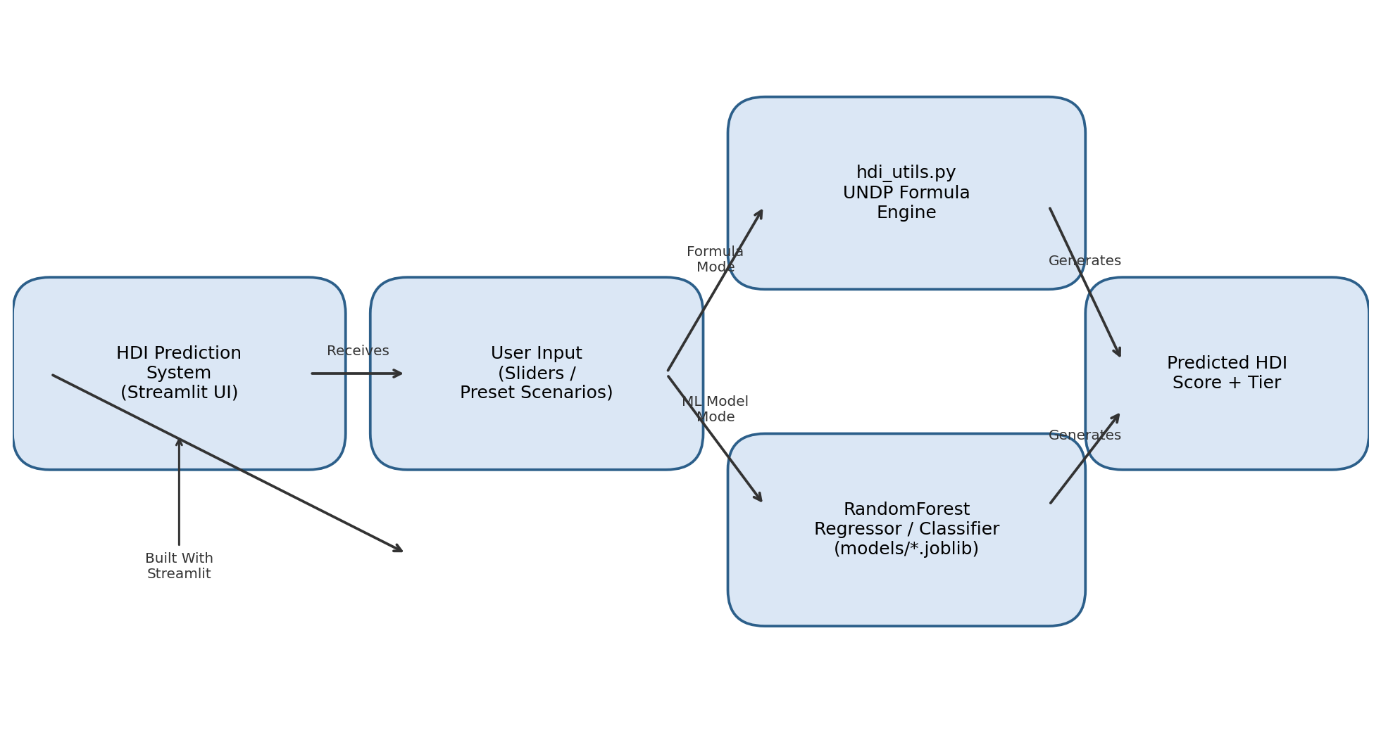
Description: The HDI Prediction System uses a lightweight two-tier architecture. The Streamlit frontend (app.py) renders sliders, preset scenarios, and prediction controls, and collects the four country indicators from the user. On submission, the request is routed to one of two prediction engines: the deterministic hdi_utils.py module, which implements the official UNDP formula (geometric mean of the Life Expectancy, Education, and Income indices), or the pre-trained RandomForestRegressor / RandomForestClassifier pair loaded from the models/ directory via joblib. Both paths return a predicted HDI score, a development tier, and the three sub-indices, which Streamlit then renders back to the user.

Pre-requisites:
- Python Programming Proficiency: Python 3.10+ knowledge, including functions, dictionaries, and basic OOP.
- Streamlit Framework Knowledge: Understanding of Streamlit's widget model (sliders, selectbox, session state, caching with @st.cache_resource).
- scikit-learn Familiarity: Comfort with RandomForestRegressor, RandomForestClassifier, and train_test_split.
- pandas / numpy Basics: Working with DataFrames and generating synthetic numeric data.
- Model Persistence: Familiarity with joblib for saving and loading trained models.
- Version Control with Git: Basic Git workflow for tracking project changes.
- Development Environment Setup: Ability to create and activate a Python virtual environment and install dependencies via pip.

Project Workflow:

Milestone 1: Model Selection and Architecture
- Activity 1.1: Define the HDI domain logic — research the official UNDP methodology (Life Expectancy Index, Education Index, Income Index) and encode the normalization bounds and classification bands.
- Activity 1.2: Research and select the appropriate ML models — evaluate regression vs. classification approaches and choose RandomForestRegressor and RandomForestClassifier for their balance of accuracy and interpretability on tabular data.
- Activity 1.3: Define the application architecture, detailing interactions between the Streamlit frontend, the formula engine (hdi_utils.py), and the ML model layer.
- Activity 1.4: Set up the development environment, installing Streamlit, scikit-learn, pandas, numpy, and joblib.

Milestone 2: Core Functionalities Development
Activity 2.1: Implement the UNDP Formula Engine (hdi_utils.py):
The core domain logic implements the official UNDP HDI methodology as a geometric mean of three normalized sub-indices:
HDI = (LEI × EI × II) ^ (1/3)

LEI (Life Expectancy Index) = (LE − 20) / (85 − 20)
EI (Education Index) = (MYS/15 + EYS/18) / 2
II (Income Index) = (ln(GNIpc) − ln(100)) / (ln(75000) − ln(100))
Classification bands follow the UNDP standard tiers:
- Very High: HDI ≥ 0.800
- High: 0.700 ≤ HDI < 0.800
- Medium: 0.550 ≤ HDI < 0.700
- Low: HDI < 0.550
Each sub-index is clamped to the [0, 1] range so out-of-bound inputs never break the composite score:
def life_expectancy_index(life_expectancy: float) -> float:
"""Normalize life expectancy at birth (years) to [0, 1]."""
value = (life_expectancy - LE_MIN) / (LE_MAX - LE_MIN)
return min(max(value, 0.0), 1.0)

def calculate_hdi(life_expectancy, mean_years_schooling,
expected_years_schooling, gni_per_capita) -> dict:
lei = life_expectancy_index(life_expectancy)
ei = education_index(mean_years_schooling, expected_years_schooling)
ii = income_index(gni_per_capita)
hdi_score = round((lei * ei * ii) ** (1 / 3), 3)
return {
"life_expectancy_index": round(lei, 3),
"education_index": round(ei, 3),
"income_index": round(ii, 3),
"hdi_score": hdi_score,
"hdi_category": classify_hdi(hdi_score),
}
Activity 2.2: Generate a Synthetic Dataset and Train the ML Models (train_model.py):
- Generate 5,000 synthetic country profiles spanning realistic ranges of life expectancy, schooling, and GNI per capita, using numpy's random generators (including a log-normal distribution for income).
- Label every synthetic row using the true UNDP formula from hdi_utils.calculate_hdi(), so the models learn a function consistent with the official methodology rather than noise.
- Split the dataset 80/20 into training and holdout sets with train_test_split.
regressor = RandomForestRegressor(n_estimators=200, max_depth=12, random_state=42)
regressor.fit(X_train, yreg_train)

classifier = RandomForestClassifier(n_estimators=200, max_depth=12, random_state=42)
classifier.fit(X_train, yclf_train)

joblib.dump(regressor, 'models/hdi_regressor.joblib')
joblib.dump(classifier, 'models/hdi_classifier.joblib')
joblib.dump(feature_cols, 'models/feature_columns.joblib')
- Evaluate the regressor with R² on the holdout set and the classifier with accuracy, then persist both models plus the feature-column order to the models/ directory via joblib.

Milestone 3: Streamlit Application (app.py) Development
Activity 3.1: Load Models with Caching: The load_models() function is wrapped in @st.cache_resource so the RandomForest models are loaded from disk once per session rather than on every rerun. If no trained models are found, the app gracefully falls back to formula-only calculation.
@st.cache_resource
def load_models():
reg_path = os.path.join(MODELS_DIR, "hdi_regressor.joblib")
clf_path = os.path.join(MODELS_DIR, "hdi_classifier.joblib")
cols_path = os.path.join(MODELS_DIR, "feature_columns.joblib")
if os.path.exists(reg_path) and os.path.exists(clf_path):
regressor = joblib.load(reg_path)
classifier = joblib.load(clf_path)
feature_cols = joblib.load(cols_path)
return regressor, classifier, feature_cols
return None, None, None
Activity 3.2: Wire Up Prediction Logic: On clicking “Predict HDI”, the app always computes the formula-based sub-indices (for display), then branches: if “ML Model” is selected and models are available, the four indicators are assembled into a single-row DataFrame (ordered by the saved feature_cols) and passed to regressor.predict() and classifier.predict(); otherwise the formula-based score and category are used directly.
if use_ml and prediction_mode == "ML Model":
input_df = pd.DataFrame([{
"life_expectancy": life_expectancy,
"mean_years_schooling": mean_years_schooling,
"expected_years_schooling": expected_years_schooling,
"gni_per_capita": gni_per_capita,
}])[feature_cols]
hdi_score = float(regressor.predict(input_df)[0])
hdi_category = classifier.predict(input_df)[0]

Milestone 4: Frontend / UI Development
Activity 4.1: Design the Sidebar Controls: Set up a sidebar with a Model status indicator (“ML models loaded (RandomForest)” or a fallback warning), a Prediction method radio button (ML Model vs. Formula-based), and a Preset Scenarios dropdown offering Custom, Very High — Developed Nation, Medium — Emerging Economy, and Low — Needs Intervention.
Activity 4.2: Build the Country Indicators Form: Lay out four inputs in a two-column grid using st.columns — Life Expectancy at Birth and Mean Years of Schooling on the left, Expected Years of Schooling and GNI per Capita (a number input with +/− steppers) on the right — each pre-filled from the selected preset.
Activity 4.3: Render the Prediction Result: The render_result() function displays a colour-coded panel (green for Very High/High, amber for Medium, red for Low) showing the development tier label and the numeric HDI score, followed by three metric cards for the Life Expectancy Index, Education Index, and Income Index.
Activity 4.4: Expose Raw Values: An expander (“See raw indicator values”) reveals the exact JSON payload used for the prediction — all four indicators plus the prediction_method — useful for debugging and transparency.

Milestone 5: Deployment
Activity 5.1: Prepare for Local Deployment: Create and activate a virtual environment, then install dependencies from requirements.txt.
D:\projects>python -m venv myenv
D:\projects>"myenv\Scripts\activate"
(myenv) D:\projects>pip install -r requirements.txt
Activity 5.2: Train the Models (one-time step): Run the training script to generate the synthetic dataset and populate the models/ directory.
(myenv) D:\projects>python train_model.py
Activity 5.3: Launch the Application: Start the Streamlit development server and open the URL it prints (typically http://localhost:8501).
(myenv) D:\projects>streamlit run app.py
Activity 5.4: Run Unit Tests: Verify the HDI formula logic against known scenarios using the included pytest suite.
(myenv) D:\projects>pip install pytest
(myenv) D:\projects>pytest tests/ -v
Important Notes:
- The ML models are trained on synthetically generated data that is consistent with the UNDP formula, not on real historical country-level HDI datasets — for production use, retrain on official UNDP Human Development Report data.
- The app is stateless: each session starts fresh with no persistent database.
- Re-run train_model.py any time to regenerate the models/*.joblib artifacts with a different random seed or sample size.

Milestone 6: Conclusion

Exploring the Application's Interface:

Home / Prediction Page:
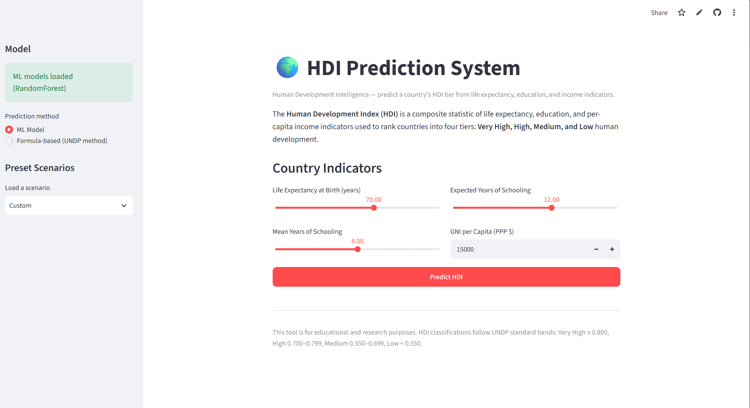
Description: The single-page Streamlit interface serves as both the landing page and the prediction tool. The sidebar shows the loaded model status (“ML models loaded (RandomForest)”), the prediction method radio (ML Model / Formula-based), and a Preset Scenarios dropdown currently set to “Custom.” The main panel introduces the HDI concept and its four development tiers, followed by the Country Indicators form with sliders for Life Expectancy at Birth and Expected Years of Schooling, Mean Years of Schooling, and a numeric GNI per Capita field, capped by the red “Predict HDI” button.

Prediction Result Panel:
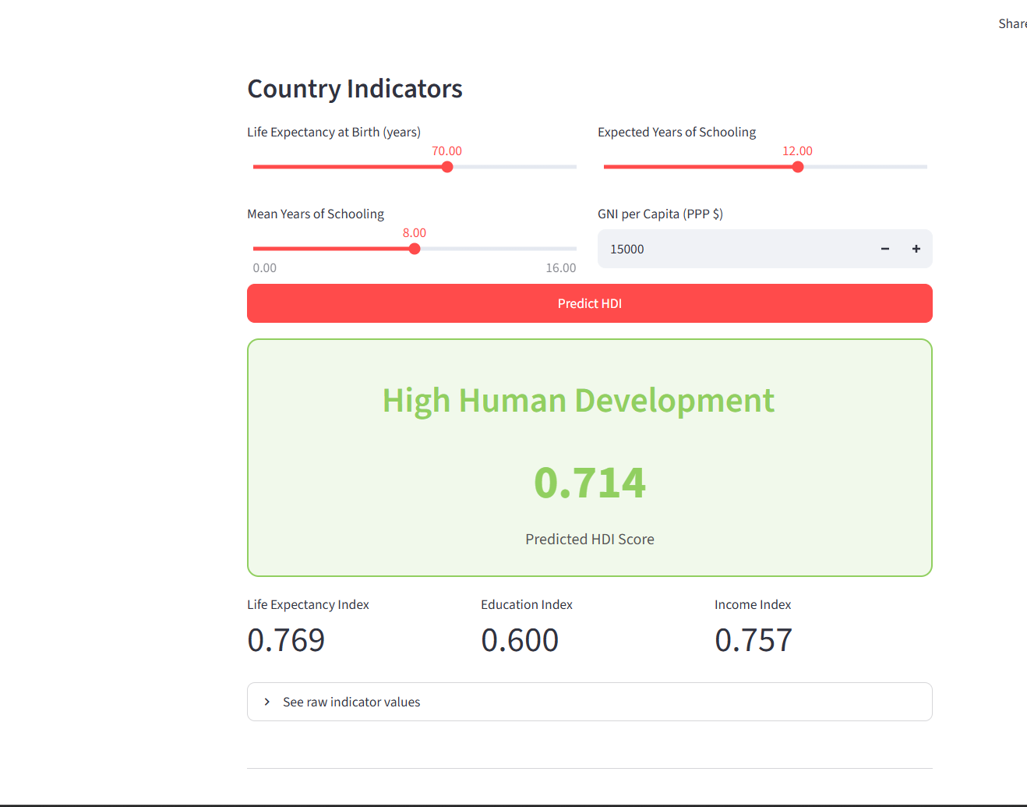
Description: After clicking Predict HDI, a colour-coded result card appears — here shown in green for “High Human Development” with a predicted HDI score of 0.714. Below the card, three metric tiles display the Life Expectancy Index (0.769), Education Index (0.600), and Income Index (0.757) that combine via the geometric mean to produce the composite score. A collapsible “See raw indicator values” panel sits beneath the metrics.

Raw Indicator Values (JSON):
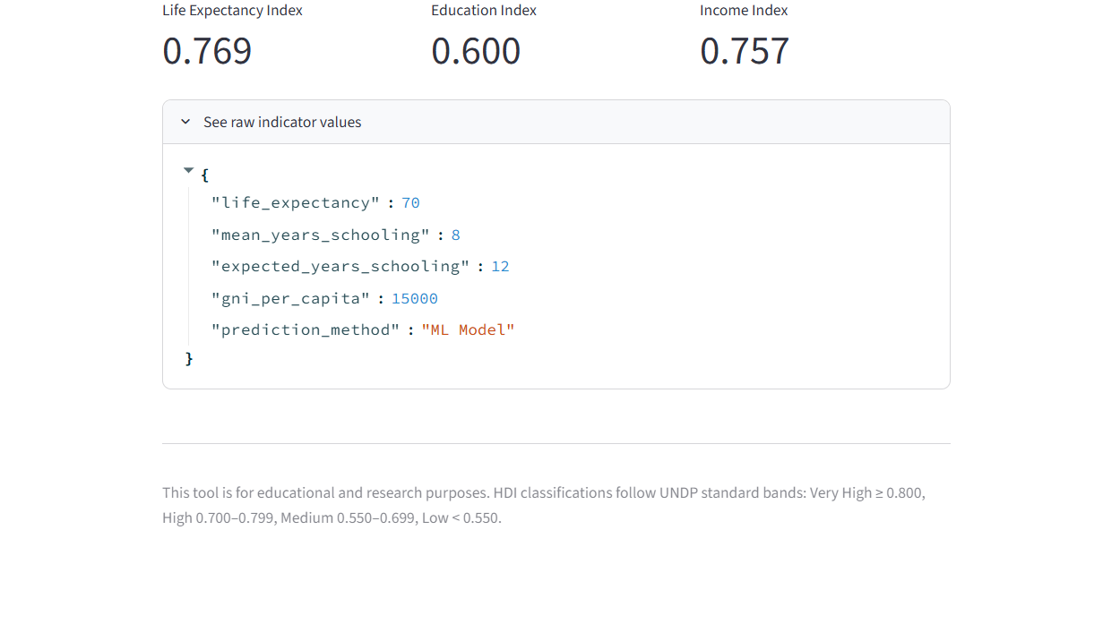
Description: Expanding “See raw indicator values” reveals the exact input payload used for the prediction as formatted JSON — life_expectancy, mean_years_schooling, expected_years_schooling, gni_per_capita, and the selected prediction_method (“ML Model”). This transparency panel lets users verify precisely which values drove the result, and the page footer restates the UNDP classification bands for reference.

Preset Scenarios Dropdown:
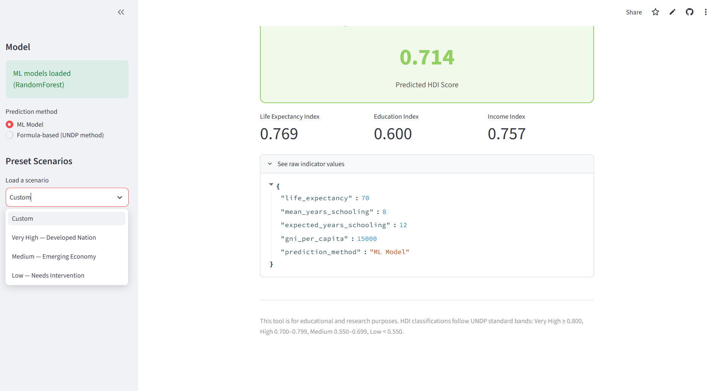
Description: The sidebar's “Load a scenario” dropdown, expanded here, offers four options: Custom, Very High — Developed Nation, Medium — Emerging Economy, and Low — Needs Intervention. Selecting a preset instantly repopulates all four sliders/inputs with representative values for that development profile, letting users explore the model's behaviour across the full spectrum of country outcomes without manual data entry.

Conclusion:
The HDI Prediction System is a Streamlit-based application that makes the Human Development Index accessible and explorable through both a transparent, formula-driven calculation and a data-driven RandomForest model pair. By combining the official UNDP methodology in hdi_utils.py with ML models trained on a formula-consistent synthetic dataset, the project demonstrates how classical statistical formulas and machine learning can be offered side-by-side so users can compare and trust the results. The built-in preset scenarios, sub-index breakdown, and raw-value transparency panel make the tool well-suited for education, research, and rapid what-if analysis of development indicators.
Looking ahead, the project has clear opportunities for expansion: retraining the ML models on real historical UNDP Human Development Report data instead of synthetic data, adding a time-series view to track a country's HDI trajectory over multiple years, supporting batch predictions from an uploaded CSV of countries, and adding user authentication to save and compare prediction history across sessions. With these enhancements, the HDI Prediction System is well-positioned to evolve from an educational prototype into a more comprehensive development-analytics tool.

